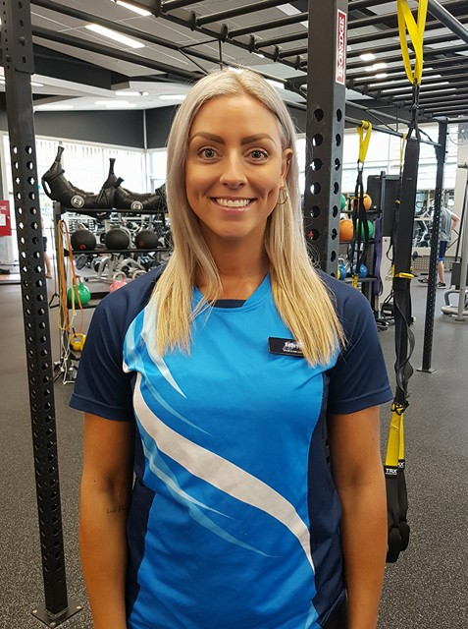

I want to teach and educate you on the importance of valuing, not just your physical body, but your mind as well. I want to help you towards looking your best and feeling your best from the inside out, in order to help you live your best, happiest, healthiest and most fulfilled life. To be well is not only to move and eat well, but to also think well.

I approach your health and training from a different perspective. Learning some basic mindset shifts to help identify and eliminate unfavourable emotional and behavioural patterns which may be affecting your health, as well as through individual programming, I aim to support each client's needs, to achieve long term health and fitness, with a well-functioning mind and body.

Through programming strength and functional training ideas, alongside muscle activation and stress-reducing recovery, I hope to create the optimal environment for your body to function well, recover well and respond to stimulus with positive changes.

Amelia

Personal Trainer Profile